Section I (12 marks)

- What is logical data independence? (2)

Logical data independence is the one which has power (Ability) to change logical schema without changing external schema or application. Logical data independence in any database applications relates to views where we can only view the data rather than modifying data.

- Consider a Relation R(A, B,C, D, E). If BC is the key of R, write all the possible super keys of R. (3)
- What is the complete set of relation algebra operations? Derive division operation using complete set. (4)
- What is the difference between trivial and non-trivial Functional Dependency? Explain with the help of example. (3)

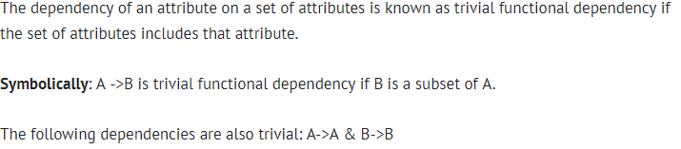

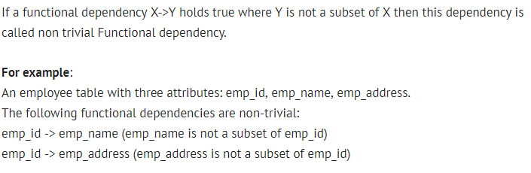

Section II (28 MARKS)
5. ER‐model
a) Construct an ER diagram for university registrar’s office. The office maintains data about each class, including the instructor, the enrolment and the time and place of the class meetings. For each student class pair a grade is recorded. Determine the entities and relationships. (4)
b) Convert the following ER diagram into relational database schema. Define a primary key for each relation. Invent key attributes for the ER diagram if they don’t have any. (6)
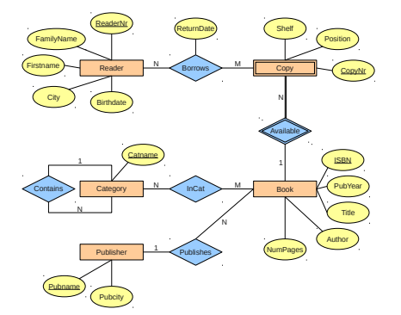
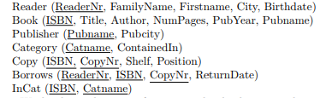
- Relational algebra
Consider a database with the following schema:
Person ( name, age, gender ) | name is a key
Frequents ( name, pizzeria ) | (name, pizzeria) is a key
Eats ( name, pizza ) | (name, pizza) is a key
Serves ( pizzeria, pizza, price ) | (pizzeria, pizza) is a key

Write a relational algebra expression for the following: (8)
- Find all pizzerias frequented by at least one person under the age of 18.
- Find all pizzerias that serve at least one pizza that Amy eats for less than $10.00.
- Find the names of all females who eat both mushroom and pepperoni pizza.

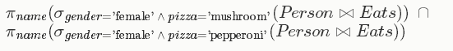
- For each person, find all pizzas the person eats that are not served by any pizzeria the person frequents. Return all such person (name) / pizza pairs.

- Functional Dependencies
- Consider a relation R(A, B, C, D, E) with FD's AB → C, CD → E, C → A, C → D, D → B. Find the list all of candidate keys. (4)

Answer : AB, C, AD

- Prove or disprove the following inference rules
  - {WY,XZ} |= {WXY} True
  - {XY,XW,WYZ} |= {XZ} True
  - {XY} |= {XYZ} False
  - {XY, Z Y} |= {XZY} True (6)
Prove using inference rules and disprove by showing a counter example.

